**Lesson 6 Demo 3**

**Setting up TestNG in Eclipse**



Steps to be followed:

1. Download and set up TestNG
2. Integrate TestNG in Eclipse

**Step 1: Downloading and set up TestNG**

1.1 Open the terminal and type the command given below to download the TestNG.

***wget http://www.java2s.com/Code/JarDownload/testng/testng-6.8.7.jar.zip***

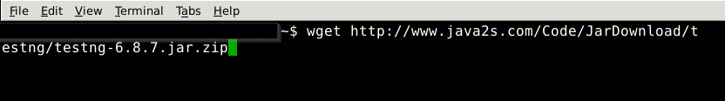

1.2 Unzip the TestNG jar file using the command given below:

***unzip testng-6.8.7.jar.zip***

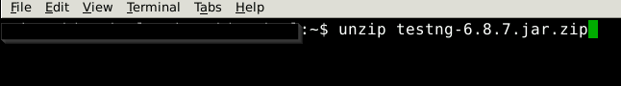

1.3 You can see the testng same as selenium server in the downloads section.

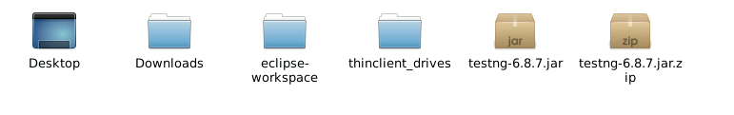

**Step 2: Integrating TestNG in Eclipse**

2.1 Go to the project in eclipse, right click on the project, select **Build Path,** and select **Configure Build Path**. Select **Libraries** and click on **Add External JARs**.... Browse and select the TestNG jar file. Refer to Lesson 6 Demo 1 to know how to configure the build path.

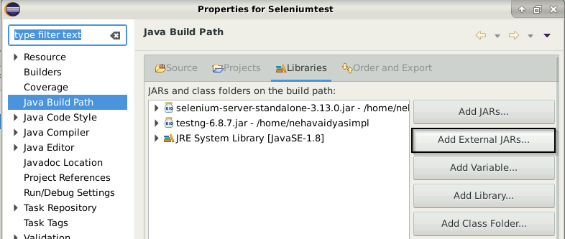

2.2 Click on **Apply and Close**.

2.3 You can see the referenced jar files for Testng as shown in the image below.

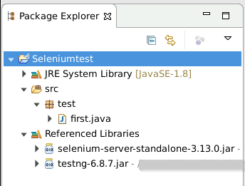



2.4 Go to the **Help** tab in the Eclipse and choose E**clipse Marketplace** to configure TestNg.

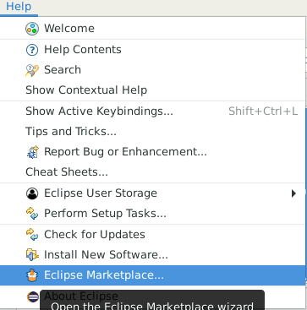



2.5 Type TestNg in the find bar and click on **Install.** Select **TestNG for Eclipse** as shown in the below screenshot.

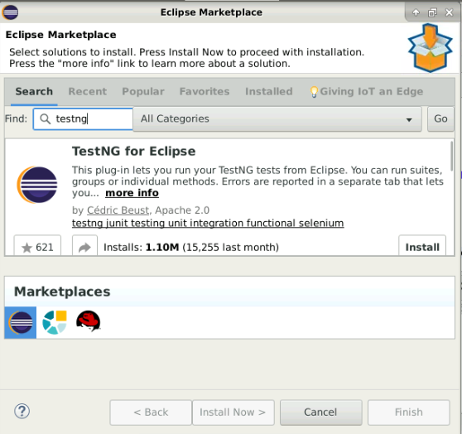



2.6 Once the installation is done, click on Confirm.

2.7 Select the checkbox **I accept the terms of the license agreement** and click on **Finish**.